Phase Changes

All matter can exist in the solid, liquid, or gaseous phases. The solid phase exists at relatively low temperatures, the liquid phase at higher temperatures, and the gaseous phase at still higher temperatures. Water is the most common example, not only because of its abundance but also because the temperatures for all three phases are common.

(Refer to the following formulas and heat constants to work on this worksheet)

latent heat (phase change - no temperature change)

fusion (melting point)Q = mL_{f}

vaporization (boiling point)Q = mL_{v}

specific heat (temperature change within a phase)

(any phase)Q =

mcΔT
Ice c = 2.10 J/gK Fusion L_{f} = 334 J/g
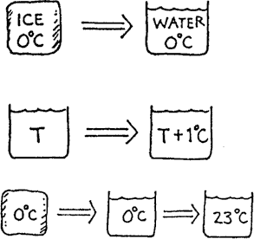
Water c = 4.19 J/gK Vaporization L_{v} = 2260 J/g where: J ≡ Joule, g ≡ grams, K ≡ Kelvin

- How many joules are needed to change 10 grams of 0ºC ice to water at 0ºC?

- How many joules are needed to change the temperature of 10 grams of water by 1ºC?

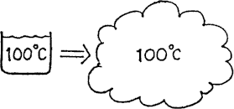
- How many joules are needed to melt 10 grams of 0ºC ice and turn it to water at a room temperature of 23ºC?

- How many joules are needed to change 10 grams of 100ºC boiling water to 100ºC steam?

- Refer to the following information for the next three questions:

A 60-gram sample of ice at 0ºC is placed in a glass beaker that contains 150 g of water at 20ºC.
  - How much heat is needed to melt the ice?

  - By how much would the temperature of the water change if it gave up this much heat to the ice?

  - What will be the final temperature of the mixture? (Disregard any heat absorbed by the glass or given off by the surrounding air.)

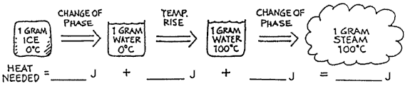
Refer to the following information for the next two questions.

Fill in the number of joules at each step below for changing the state of 1 gram of 0º ice to 100ºC steam.

- Why is it difficult to make tea on the top of a high mountain?

Refer to the following information to do the next three questions:
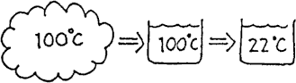
One gram of steam at 100ºC condenses, and the water cools to 22ºC.
  - How much heat is released when the steam condenses?

  - How much heat is released when the water cools from 100ºC to 22ºC?

  - How much heat is released altogether?

Refer to the following information to do the next three questions
In a household radiator 2000 g of steam at 100ºC condenses, and the water cools to 90ºC.

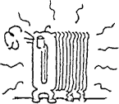
  - How much heat is released when the steam condenses?

  - How much heat is released when the water cools from 100ºC to 90ºC?

  - How much heat is released altogether?
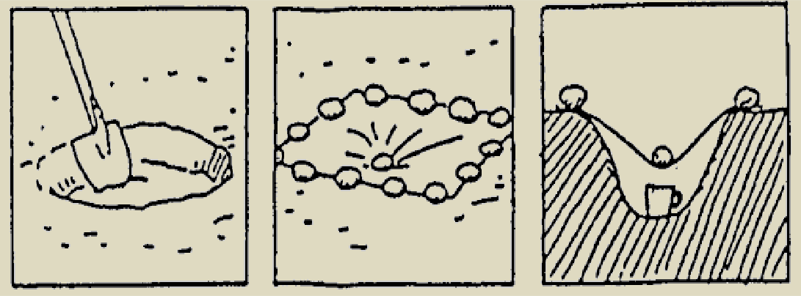
9. Refer to the following information for the next question.

To get water from the ground, even in the hot desert, dig a hole about a half meter wide and a half meter deep. Place a cup at the bottom. Spread a sheet of plastic wrap over the hole and place stones along the edge to hold it secure. Weigh the center of the plastic with a stone so it forms a cone shape.

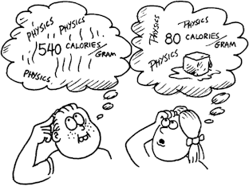
    - Why will water collect in the cup? (Physics can save your life if you're ever stranded in a desert!)

- What is the amount of 100°C steam required to melt one gram of 0°C ice?

- How many grams of 0°C ice can be melted by one gram of 100°C steam?

- A student slowly heats a beaker of a liquid on a hot plate. The liquid has a boiling point of 78°C. The student makes the graph shown below from the data she records as the liquid is heating.
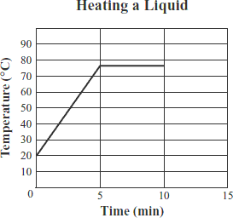

Which of the following statements best describes what happens to the molecules of liquid between 5 and 10 minutes of heating?

  - The mass of the molecules increases.
  - The molecules undergo a chemical change.
  - The molecules absorb energy to change phase.

  - The average kinetic energy of the molecules decreases.
- The graph below shows the temperature of a sample of water as it is heated at a constant rate.
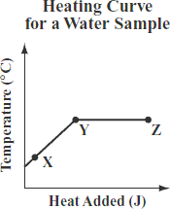

Which of the following conclusions is best supported by the information in the graph?

A. The water boils between points X and Y and condenses between points Y and Z.
B. The average kinetic energy of the water molecules increases between points X and Y and stays the same between points Y and Z.
C. The water evaporates between points X and Y and the average kinetic energy of the water molecules increases between points Y and Z.
D. The average kinetic energy of the water molecules remains the same between points X and Y and the water boils between points Y and Z.

- Why do various substances have different boiling and freezing points? Would you expect the latent heats to be different?
- Explain why the latent heat of vaporization of water is almost seven times greater than the latent heat of fusion.

- Why do some liquids evaporate more readily than others?

- People traveling in hot region sometimes carry water in a porous canvas bag hung on the front bumper of a car or truck. What is the purpose of this?

- (a) Why do we sometimes blow on the surface of a hot cup of coffee or a spoon full of hot soup?

(b) In some states, highway signs warn: “Bridge freezes before road”. Why is this?

- To tell the wind direction, people sometimes wet a finger and hold it up. How does this help?

- Why do ice cubes in a refrigerator freezer get smaller with time, particularly in a frost-free freezer?

- Fogs may be thought of as low-lying clouds. Why do fogs sometimes form in valleys overnight?

- (a) Why does the mirror in the bathroom fog up when you take a shower?

- Why does water condense on the outside of a glass containing an ice drink?

- Why can you “see” your breath on a cold day?

- When a tea-kettle boils, we say we can see the steam coming from the spout. Is this correct? Why?

- Freeze-dried coffee crystals are made from frozen coffee. How is this done?

- A pan of water on a stove boils “faster” when the burner is on high heat, and boils “slower” with the burner on low heat. Is the temperature of the water greater for a fast boil? Explain.
- Perfumes and colognes have an alcohol base. Why not use water, since it would be cheaper?

- Why does covering a pot of water with a lid help the water boil hotter and more quickly?

- Automobile cooling systems operate under pressure.

- What is the purpose of this?

- What would happen if your removed the radiator pressure cap immediately after turning off a hot engine, and why? (Don’t try this it is very dangerous)
- The antifreeze (ethylene glycol) used in automobile cooling systems has a freezing point of -11.5⁰C, which is lower than that of water. Why don’t we replace the water completely with antifreeze?

- Is regelation an important factor in making snowballs? If so, why can’t balls be made from dry powdered snow?
Refer to the following information for the next three questions.

29. REVIEW: A can of juice at 20⁰C is completely submerged in a closed, insulated container filled with water at 4⁰C.

  - Describe what happens to the temperature of the can of juice and the temperature of the water in the container within the first few minutes after the can is submerged. Explain your answer.

  - After four hours, will the can and the water have the same temperature or different temperatures? Explain your answer.

  - Estimate the numerical value(s) of the final temperatures of the can of juice and the water after four hours. Explain your answer.

30. REVIEW: Two blocks of zinc with different masses are at room temperature. Each block then absorbs the same amount of heat over 10 minutes. When the temperature of each block is then measured, block 1 is at a higher temperature than block 2. Which of the following statements most likely describes the zinc blocks?

A. The mass of block 1 is less than the mass of block 2.
B. The mass of block 1 is greater than the mass of block 2.
C. The specific heat of block 1 is less than the specific heat of block 2.
D. The specific heat of block 1 is greater than the specific heat of block 2.

